
CANDIDATE NAME
CIVICS GROUP
TAMPINES MERIDIAN JUNIOR COLLEGE JC2 PRELIMINARY EXAMINATION

_________________________________________________________________________________ H2 GEOGRAPHY 9173/01
Paper 1 18 September 2025 3 Hours
INSERT

___________________________________________________________________________ READ THESE INSTRUCTIONS FIRST
This Insert contains all the Resources referred to in the questions.
_________________________________________________________________________________ This document consists of 7 printed pages.
2

Resource 1 for Question 1
GDP growth of selected ASEAN Countries, % year-on-year
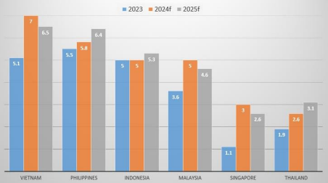

Resource 2 for Question 1
US tariffs on different ASEAN countries with proposed additional tariffs 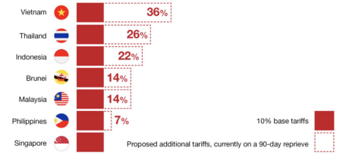
*10% Base tariffs mean that the imported products would be subjected to a tax of 10%, a product that cost $10 would now have a total cost of $11 to the importer. Companies that bring in foreign goods into the US must pay the tax to the US government.
**After 90 days, there could be additional tariffs implemented which vary from country to country
Tampines Meridian Junior College 2025 JC2 Preliminary Examination H2 Geography
3
Resource 3 for Question 1
ASEAN nations export to major destinations
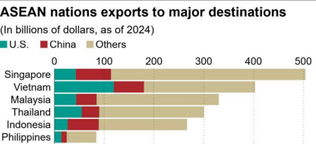
Resource 4 for Question 1
2023 SDG levels and trends for ASEAN countries on Select SDG indicators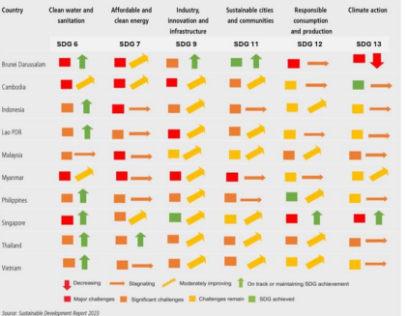Tampines Meridian Junior College 2025 JC2 Preliminary Examination H2 Geography
4
Resource 5 for Question 2
Map and climograph of Dhaka, Bangladesh
Tampines Meridian Junior College 2025 JC2 Preliminary Examination H2 Geography
5
Resource 6 for Question 2
River discharge measured at Padma River, Bangladesh
Tampines Meridian Junior College 2025 JC2 Preliminary Examination H2 Geography
6
Resource 7 for Question 2
Forecast track of Tropical Cyclone Remal over North Bay of Bengal
*Date and Time: Day.Month.Year / Time (based on 24-hour format)
Tampines Meridian Junior College 2025 JC2 Preliminary Examination H2 Geography
7
Resource 8 for Question 2
Land cover maps of Dhaka metropolitan area from 1989 to 2009
Source: https://pubs.sciepub.com/jgg/5/2/1/figure/5
Tampines Meridian Junior College 2025 JC2 Preliminary Examination H2 Geography

